United Way of St. Clair County

Campaign Coordinators Handbook

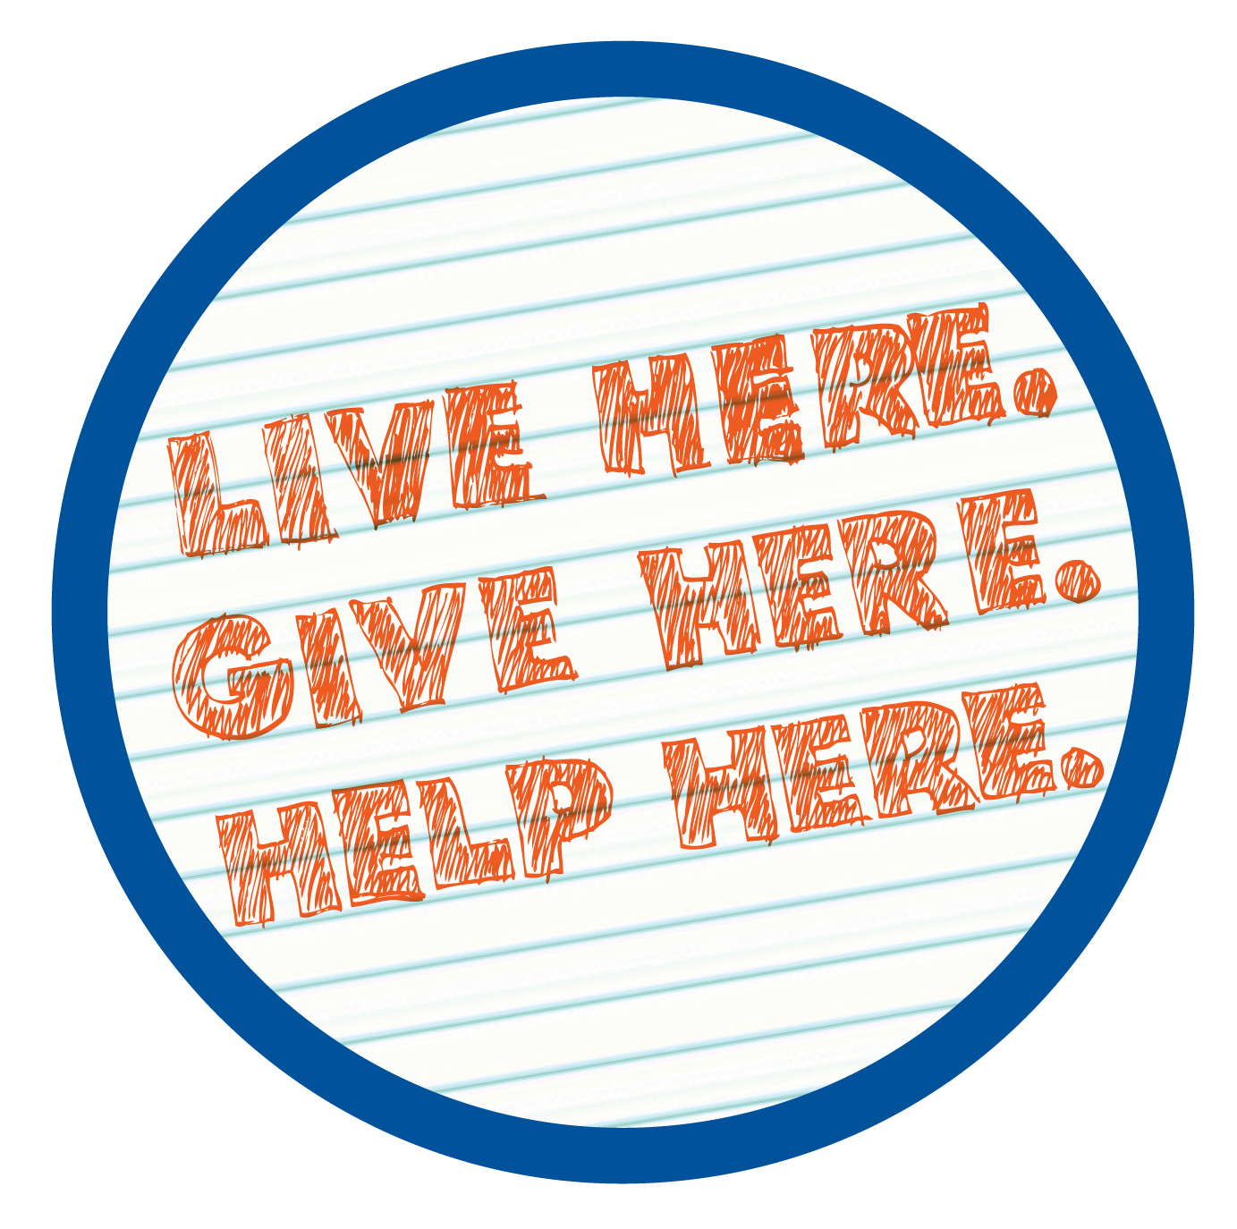

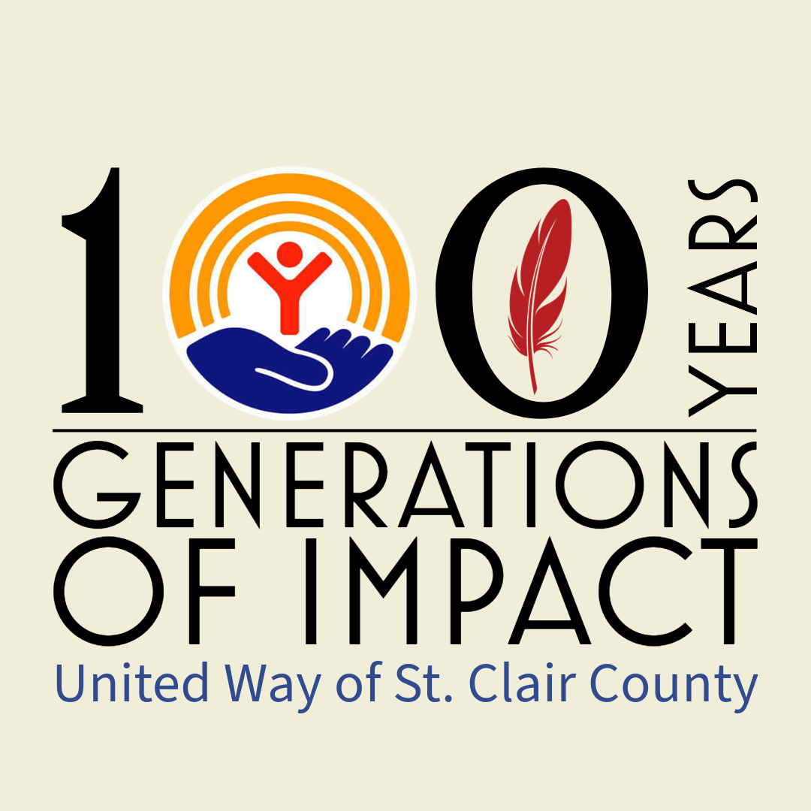

Welcome!
Dear Campaign Volunteer:

Congratulations! Thank you for serving as Out Reach Volunteer for the 2024 United Way of St. Clair County Campaign (UWSCC). Your selection is an honor given to you because of your leadership, ability, and enthusiasm.

You are about to begin a challenging, fun, and rewarding experience. Please take advantage of all the information and resources available to you and you will be sure to have a successful Community Campaign.

Most of all, keep in mind why we are all involved in this important effort. It’s not just about dollars! It’s about changing lives…right here in St. Clair County. It’s about helping our friends, our family, and our neighbors. It’s about teamwork and knowing that together, we can have a real impact on our community’s most pressing needs.

Thank you for being part of the team that reaches out a hand to one and influences the condition of all.

United Way of St. Clair County Contacts

Name | Title | Talent | Phone | E-mail
Brent Gillette | Executive Director | Good back-up | 985-8169  X118 | bgillette@uwstclair.org
Paul Henderson | Resource Development Director | Help with Campaign issues | 985-8169  X120 | campaign@uwstclair.org
Cathy Sherman | Finance Manager | Financial reporting | 985-8169  X111 | finance@uwstclair.org
Tara Raney | Community Impact | Stats/Data | 985-8169  X111 | comm.impact@uwstclair.org

2024 Campaign Timeline

Time Frame Activity

September 9-13, 2024 Campaign Blitz – pick up materials and make calls to CEO’s to
Meetings regarding their campaign

September 4, 2024 Campaign Kick Off – 5 p.m.
(Solitude Links)

September 16 - November 16 Schedule your employee campaigns. Make it informative and fun!
Let us help, give us a call (810) 985-8169. Please send updates
to keep us informed about your progress.

October 16, 2024 Mid-Way Push
(TBD)

December 16, 2024 Campaign Culmination. Additional wrap-up activities may continue.

By January 10, 2025 Send final report to United Way of St. Clair County in the report envelope. Call (810) 985-8169 for pick up.

Make sure you submit all pledge information to the company’s payroll dept.

Campaigns do not need to end at this time. Continue to work on those workplaces that need additional time. Call (810) 985-8169 for additional assistance.

March 17, 2023 St. Patty’s Day Breakfast
Details to be announced.

TBD Campaign Celebration/Annual Meeting Details to be announced.

Best Practices

- Encourage active, visible CEO involvement

- Appoint an effective Employee Campaign Coordinator (ECC) who is invested and enthusiastic

- Analyze previous year’s campaign

- Meet with your United Way Representative

- Recruit a campaign committee “A Winning Team”

- Set a challenging campaign goal

- Solicit your prospective donors (group or individual meetings). The goal is 100% contact!

- Hold a Kickoff Event (Be Creative)

- Report your results and celebrate your achievements!

- Say THANK YOU!

Facts and Figures
- What is raised locally – stays HERE … 98% of donors’ giving goes to programs.
- Last year … $850,000 was raised to fund 20 affiliated organization HERE.
- Nearly 40 funded programs served our county, cities, townships & villages – and over 8,000 residents have been directly helped. It could be a neighbor or family member who has benefitted from a service that is United Way funded.

- Being a United Way organization means maintaining a high standard through national accreditation with local governance making funding decisions that are relevant to our local community needs.

- Choice - you can choose where your donation is directed.
- We emphasize Our 4 Impact Areas … Helping through Education/Training, Improving Quality of Life through Health & Advocacy, Reducing Emergency Services and Teaching Youth Life Skills.

- We support giving though education & understanding.

So what does the 2024 UW team look like?
23 volunteer board members
20 volunteer citizens review committee members
4 paid staff members
Many community volunteers who make it happen … including YOU!

Thank you for your support in 2024—we couldn’t do it without you.

THANK YOU!
United Way Affiliated Organizations

The Arc of St. Clair County 810.989.9144

Blue Water Area Rescue Mission (B-Warm) 810.956.0768


Blue Water Community Action 810.982.8541

Blue Water Safe Horizons 810.989-5246

Boy Scouts Michigan Crossroads Council 810.235.2531

Catholic Charities of Southeastern Michigan (Port Huron) 810.987.9100

Community Enterprises of St. Clair County 810.982.3261

Community First Health Centers 586.270.8055


Council on Aging, Inc., serving St. Clair County 810.987.8811

Detroit Rescue Mission 313.993.6703


The Harbor 810.982.8584

Hemophilia Foundation of Michigan 734.544.0015
I.M.P.A.C.T. (Center for Human Resources) 810.985.5437
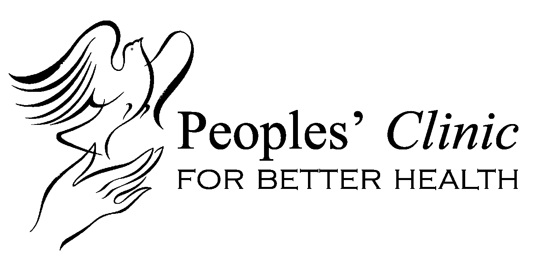
Peoples' Clinic for Better Health 810.985.4747

Sanborn Gratiot Memorial Home 810.985.5631
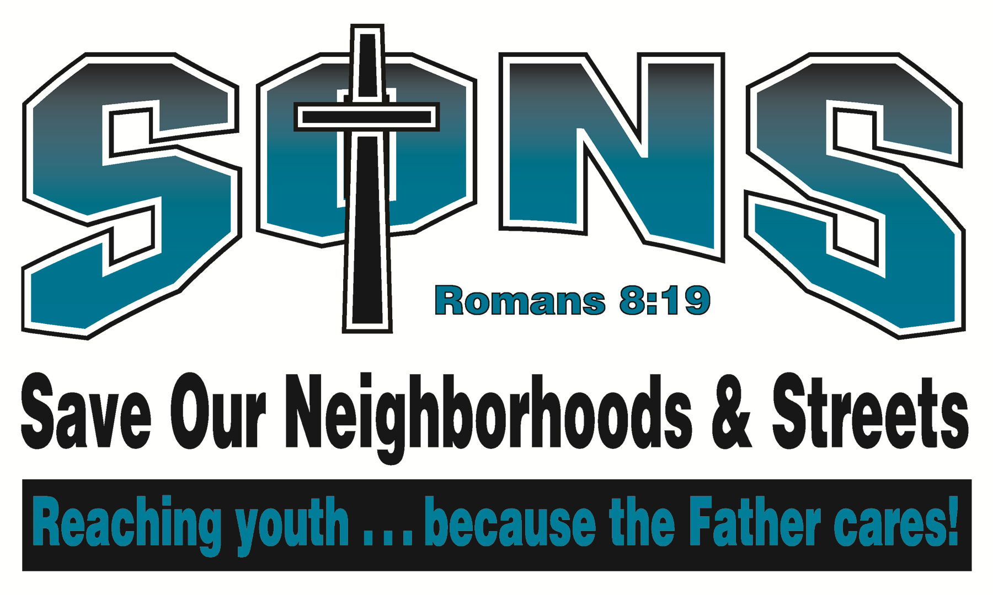
S.O.N.S. (Save our Neighborhoods and Streets) 810.989.7667

Touchstone Services, Inc. (Blue Water Clubhouse) 810.985.9118
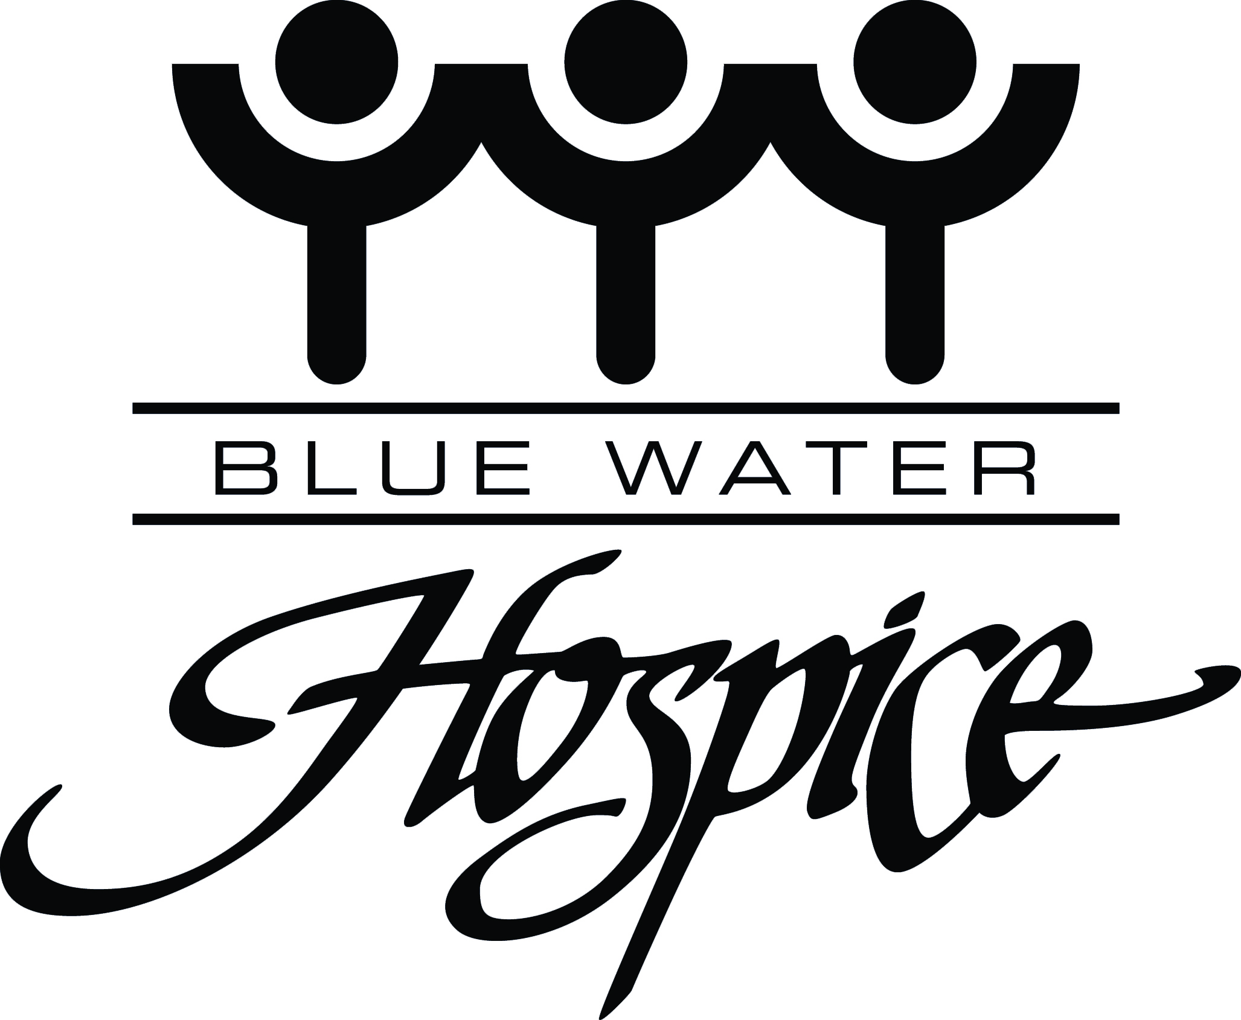

&
Visiting Nurse Association Services & Hospice Home 810.984.4131

Top ten reasons to give to United Way
10 Because we all make a living by what we get, but we make a life by what we give.
9 Because a strong community is a good place to call home.
8 Because you will be in good company!
7 Because it’s people caring for people.
6 Because it gives people in need a reason to smile.
5 Because it lends a helping hand close to home.
4 Because it builds a healthier community.
3 Because it raises spirits, raises hope, and gives everyone a chance to help.
2 Because it’s not enough to give people a night of shelter; you’d rather make sure they’re not homeless in the first place.
And the
#1 reason…..Because once upon a time, someone helped you.

Steps to Success (detailed in following pages)
- Meet With Your United Way Representative

- Get Your CEO/Top Management Involved

- Recruit a Winning Team

- Set a Challenging Campaign Goal

- Publicize Your Campaign

- Be Creative

- Conduct Your Campaign

- Report Results

- Say Thank You
Step 1

Meet With Your United Way Representative
Your United Way representative will be either a member of the United Way staff or a specially trained volunteer from a company or organization in the area. Call (810) 985-8169 or email campaign@uwstclair.org for information.

Step 2

Get Your CEO/Boss Involved
The support of your CEO and top management is essential to a successful campaign. Keep them informed and involved by asking them to:

• Send a special letter to each employee encouraging participation in the United Way campaign.
• Make a personal gift to United Way.

Sample CEO Endorsement E-mail Message:

Dear Employees:

During the next few weeks, you will be hearing a great deal about our local United Way. (Company) recognizes the important and ongoing human services being provided to thousands of people in our community by United Way funded programs.

Please take time this year to learn more about how United Way is making our community a better place to live and consider joining me and many other employees who contribute.

The decision to give is personal. Perhaps one day you, your family, a co-worker or a friend will need the help of one of United Way’s member agencies. Let’s ensure that those services will be available. Make a choice that really matters. Please join me in giving to United Way.
Thank you.

Sample CEO Endorsement Letter:

Dear Employees:

I am pleased to announce the beginning of our United Way Campaign. We support this campaign because United Way impacts all of us.

I ask for your support of this campaign because so many people desperately need your help. Did you know that (include some information about United Way that will interest your employees) ?

By donating to United Way of St. Clair County, you directly address these issues. But, it’s not just about addressing the issues. United Way is focused on impacting the community by focusing on
what matters most . . . changing lives.

Our employee campaign is scheduled to begin on (date), and (name) has been designated as our campaign chair. When you are asked to contribute, please give generously. Our payroll deduction plan is a convenient way for you to fulfill your pledge.

Step 3

Recruit a Winning Team
Don’t try to do everything yourself. Get a team together and make the job easier – and more fun!

• Elect a co-chair to support your role and serve as next year’s chair.

• Include people from all levels of your organization.

• Assign specific duties that use each team member’s skills, talents, and interests.

• Set a schedule for the campaign and plan to meet regularly.

• Set a goal.

• Establish your employee campaign goal by considering the previous year’s campaign results.

Step 4

Set a Challenging Campaign Goal
Set goals based on increases in:
Involvement – give everyone the opportunity to give. Encourage participation through positive campaigning.
Average giving – encourage those who participate to up their gift amount from previous years.
Leadership Giving – encouraging those who are able to give at Leadership level and increasing this number of high level givers.

Step 5

Publicize Your Campaign
Promote your campaign as a short, fun event that happens once a year. It is important that employees know the campaign is coming so they are prepared to make a financial contribution. Just a few communication ideas:

- Group presentations
- Letter from your CEO
- Speakers and Tours program
- Posters
- Brochures
- Article in company newsletter or story/letter posted on bulletin board
- Voice and e-mail messages
- Campaign thermometers – at the building entrance, in break rooms, on the bulletin board
- Pledge cards
- Fliers about incentive items
- Decorate break rooms with United Way information – posters, etc.
- Balloons
- Children’s art contest with a United Way theme
- Company payroll stuffer/United Way message on pay stub
- Employee testimonials
- Personalized company campaign video
- Food and/or clothing drive for a United Way agency
- United Way quiz
- Screen saver
- Did You Knows (Flyers on Stats)
- Intranet

These ideas can be used to develop understanding about United Way, increase volunteerism, build excitement and reward your campaign team. They make a great addition to, but do not replace, employee meetings and the ask.

Step 6

Conduct Your Campaign
Now it is time to decide how potential donors will be asked to give. There are two proven methods for workplace campaigns — group meetings and individual meetings.

Initial Considerations:
1. Give everyone the opportunity to give – make sure all employees, in all locations, on all shifts are asked to consider giving. Your objective should be 100% contact.
2. Remember Giving Is A Personal Decision. No one should ever be forced to give.

Method | Benefits
Group  Group meetings may follow a variety of forms; however, the essential messages include a clear explanation of the campaign’s objectives and an enthusiastic, positive request for contributions. Pledge forms may be returned at the meeting, in follow-up visits, or through other means, such as e-pledging or drop boxes. | • This is our recommended campaign approach.  • Guarantees uniform exposure to the United Way  message.  • Removes prospective donors from the  distractions of the work area.  • Efficient use of your organization’s time.
One-on-One  Immediately following your kickoff event, your team members approach assigned individuals to personally share the company’s goals, request a new or increased gift, answer any questions, and receive the pledge. | • Ability to tailor the United Way message to each  individual.  • Opportunity for the contributor to ask questions  and receive immediate responses.  • Respects the privacy of the individual.  • Affords a greater opportunity to secure an  increased gift.  • Works especially well for Leadership Givers.

Selecting Your Team:

• The people you select should be committed United Way donors. It is most difficult to ask someone to
do something they are not committed to doing.

• Volunteers are your most effective and enthusiastic team members. Ask for people who already give
of their time to help others in the community.

• Your team should be representative of the entire workforce. Include people from all parts of the
organization.
Kicking Off Your Campaign—Sample Rally Agendas

The 15 Minute Rally

Welcome and Endorsement of United Way | Chief Executive | 4 Minutes
Campaign Objectives and Timetable | Employee Chairperson | 1 Minutes
Volunteer Speaker | United Way Speaker | 2 Minutes
Campaign Video |  | 6 Minutes
Request to Give/Closing Remarks | Employee Chairperson | 2 Minutes

The 20 Minute Rally

Welcome and Endorsement of United Way | Chief Executive | 2 Minutes
Campaign Objectives and Timetable | Employee Chairperson | 2 Minutes
Volunteer Speaker | United Way Speaker | 8 Minutes
Campaign Video |  | 6 Minutes
Request to Give/Closing Remarks | Employee Chairperson | 2 Minutes

The 30 Minute Rally

Welcome and Endorsement of United Way | Chief Executive | 3 Minutes
Labor Endorsement, if applicable | Union President | 2 Minutes
Campaign Objectives and Timetable | Employee Chairperson | 3 Minutes
Volunteer Speaker | United Way Speaker | 13 Minutes
Campaign Video |  | 6 Minutes
Request to Give/Closing Remarks | Employee Chairperson | 3 Minutes

Step 7

Have Fun — Fun Campaign Ideas
It always feels good to help others but here are just a few ideas to make your employee campaign FUN:

• Themes
United Way World Wide campaign theme is “Live United” and the campaign materials reflect this message. UWSCC is using “Make a Difference, be an Every Day HERO!” You may use these themes or create your own. Weave your theme into campaign events and materials using the United Way logo. Tie your theme to your company’s logo, advertising slogan or industry.

Examples of themes might include:

- Football
- Halloween
- Circus
- Sports
- Oktoberfest
- Olympics
- Have a contest to select a theme

• Incentives
Utilize incentives to get pledge cards in early or to encourage participation, increased giving or department competitions. Remember, people give when they are educated about the needs and the impact of their gift, but incentives are a fun addition to the campaign.

Some suggestions for incentives for turning in a pledge card are:

- Angel Day (day off with pay)
- Reserved parking
- Tickets to sporting events
- United Way T-shirts and other merchandise
- Movie/theater passes
- Company T-shirts
- Dinners for two
- Hotel stay giveaways
- Gift certificates
- Airline tickets
- Company merchandise
- Casual dress days
- CEO to wash their car
- Cups/mugs

• Organization Speakers

• Games/Contests

- Costume contest
- Prettiest baby
- “Guess Who” contest using old school pictures of employees
- Volleyball, softball, or bowling tournament

• Give-Aways*

- United Way pins
- NFL schedules

There are many more giveaway items and awards available for purchase at the United Way Store.
Visit http://www.unitedwaystore.com/ or call 1-800-772-0008 for more information.

• Food Events

- Ice cream social
- Bake sale
- Best dessert contest

Special Events

Special events are your opportunity to add a little something extra to the campaign! Not only do they raise extra funding for United Way, but they can be instrumental in team development and great for company spirit! Use this as an opportunity to further educate your employees about United Way and most importantly, have FUN! And remember, not every special event has to be elaborate!
- Be creative
- Events should be strategically scheduled throughout the campaign to be
most successful
- Make it easy for employees to participate
- Secure the support of upper management
- Involve a team in the planning and implementation process
- Have fun!

Remember… when planning special events please stress that the support of the activities is
in addition to the individual campaign pledge.

Step 8

Report Your Results
It is very important to report your results to United Way as soon as possible following the completion of your campaign. Contact Finance Director 985-8169 or email finance@uwstclair.org if you have any questions.

- Make sure all pledge cards are returned and accounted for. Turn all payroll deduction sheets in to your payroll office.

- Summarize all campaign information on the report envelope. Enclose cash, checks, and copies of all pledge forms.

- Drop your report envelope(s) at the United Way office. You might call first because our little staff gets spread thin during campaign time. All report envelope(s) should be submitted to United Way immediately after the conclusion of the campaign so as to avoid delays in the processing of pledges and contributions.

- Report final results to your fellow employees and thank them for participating.

- Submit your report envelopes no later than January 31, 2023.

Step 9

Thank Everyone
- Publicize your campaign results
- Recognize campaign committee and employee solicitors
- Recognize employees and departments that had great results
- Share with employees the difference their gifts make
- Have a thank you reception

Sample Thank You Letter

Dear _____:

Congratulations! Your generous contribution to the United Way campaign has helped us reach an all time high. Thanks to your efforts, we were able to raise a total of $_______ for an increase of ___ percent over last year.

Although the results are gratifying, they come as no surprise. I have long been aware of your generosity and willingness to work together for the greater good of the community. Thanks to you, United Way of St. Clair County can continue to focus on what matters most . . . investing in the building blocks for a good life.

Sincerely,

(CEO or Employee Campaign Coordinator signature)
Campaign Work Plan
You will likely want to add interim steps to each of those listed below.

Task | Who? | How? | When?
Meet With Your United Way Representative
Get Your CEO/Top Management Involved
Recruit A Winning Team
Set A Challenging Campaign Goal
Publicize Your Campaign
Be Creative
Conduct Your Campaign
Report Results
Say Thank You

NOTES

